Software Project Management Plan

Customer Transaction Portal
9/29/2019

Team Members
Kenneth Harris
Jorge Lopez-Flores
Scott Peery
Nicholas Wiegand

Document Control

Change History
Revision | Change Date | Description of changes
V1.0 | 9/29/2019 | Initial release

Document Storage
This document is stored in the project’s GitHub repository at: https://github.com/umkc-cs-451-2019-fall/semester-group-assignment-group-4/blob/master/CommerceBank/Project%20Documents/Team%204%20Project%20Plan.doc

GitHub Repository Parent Folder:
https://github.com/umkc-cs-451-2019-fall/semester-group-assignment-group-4

Document Owner
Kenneth Harris is responsible for developing and maintaining this document.
Table of Contents
1 Overview 4
1.1 Purpose and Scope 4
1.2 Goals and Objectives 4
1.3 Project Deliverables 5
1.4 Assumptions and Constraints 5
1.5 Schedule and Budget Summary 6
1.6 Success Criteria 6
1.7 Definitions 7
1.8 Evolution of the Project Plan 7
2 Startup Plan 8
2.1 Team Organization 8
2.2 Project Communications 8
2.3 Technical Process 9
2.4 Tools 9
3 Work Plan 9
3.1 Activities and Tasks 9
3.2 Release Plan 9
3.3 Iteration Plans 10
3.4 Budget 10
4 Control Plan 11
4.1 Monitoring and Control 11
4.2 Metrics Collection 11
5 Supporting Process Plans 12
5.1 Risk Management Plan 12
5.2 Configuration Management Plan 12
5.3 Verification and Validation Plan 13

Overview

Purpose and Scope

Commerce Bank Customers need a way to quickly and easily review the transactions that have taken place in their back account. Additionally, they would like to be notified when certain activity takes place in their account (duplicate transactions, etc.) and be able to customize and implement criteria for when a transaction ought to trigger such a notification. This will allow them to quickly glance over their account, see if there are any issues, and if there are, quickly identify them. Commerce Bank employees, then, need access to see the same data and make changes, if necessary, to fix errors.

At minimum, the application will allow users to view all their transaction data, customize business rules, receive notifications based on those rules, and print data reports. Time permitting, we could expand towards stretched goals assigned by Commerce such as server deployment, creating a web API layer, security testing/optimization, etc, as well as any original and useful ideas from the development team.

Goals and Objectives

Project goals:
1. Establish a web portal for bank account transaction data.
2. Create a portal that both customers and administrators can use intuitively.
3. Create a tool for customers to create and edit business rules related to their account, as well as view and export data related to those rules.
4. Create a system that notifies users about their transaction data and business rules.

Project Objectives:
1. Create a home page with a basic list of transactions, sorted by date.
2. Create a database for customer data
3. Create a user-interface to add/edit/update/delete business rules.
4. Create notification system to alert users based on business rules.
5. Allow data to be imported and exported via excel.
6. Create interface for customers to view business rules/notification data.

Project Deliverables

The following items will be delivered to the customer on or before 12/07/2019:
- Source code for both the client and server portions of the system.
- User’s Guide
- System Administrators Manual
- Test Plan
- System test Cases
- Suite of regression tests

Assumptions and Constraints

Assumptions:
1. The local instance of the application and database works on test hardware.
2. Integration of the application into a website is feasible (we are not assuming integration into any particular website).
3. The team will meet at least once a week to track and estimate progress.
4. Consultation with Commerce Bank on project vision and limited technical assistance, if necessary, is available.

Constraints:
1. The software must run on Windows.
2. The database must be created using Microsoft SQL Server.
3. The architecture will be coded using ASP.NET MVC.
4. The front-end view will be coded using the React API.
7. Intellectual property of the project sponsor may not be used without explicit permission.
6. The software must be ready by 12/07/2019.

Schedule and Budget Summary

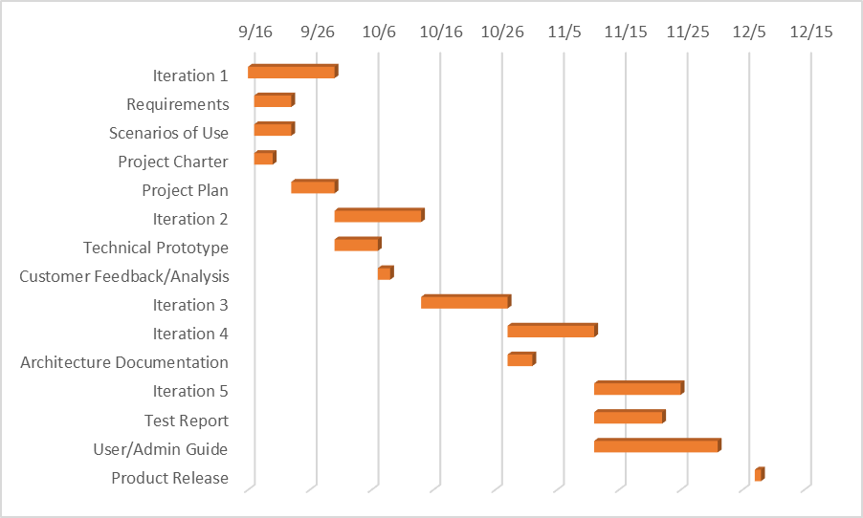

Budget Summary:
1 project manager at 5 hours per week for 10 weeks 50 hours * $50/hr = $2500

1 requirements engineer at 5 hours per week for 10 weeks 50 hours * $45/hr = $2250

2 software engineers at 5 hours per week each for 10 weeks 100 hours * $45/hr = $4500

200 hours total, $9250 total, avg, $47 per hour

Success Criteria
- Total project cost does not exceed 20% of the above estimate ( Section 1.5)
- All baseline requirements and high-priority use cases are delivered on 12/07/2019

Definitions

Commerce Bank Web Application (CBW) - the product that is being described here; the software system specified in this document.
Project - activities that will lead to the development of the CBW.
Product – what is being described here; the software system specified in this document.
Client – Commerce Bank; the organization for whom the application is being built.
User – the person or persons who will actually interact with the application.
Use Case – describes a goal-oriented interaction between the system and an actor. A use case may define several variants called scenarios that result in different paths through the use case and usually different outcomes.
Actor – user or other software system that receives value from a use case.
Scenario - one path through the use case.
Role – category of users that share similar characteristics.
Controls – the individual elements of a user interface such as buttons and drop-down boxes.
Developer - the person, persons, or organization developing the system, also sometimes referred to as the supplier.
Stakeholder – anyone with any interest in the project and its outcomes. This includes clients, customers, users, developers, testers, managers, and executives.

Evolution of the Project Plan

Before each iteration, the project plan will be updated to include a schedule of detailed tasks for the upcoming sprint. Each week the team will meet to discuss progress, update actual hours, and further specify/adjust the following week’s schedule if necessary. Risk mitigation will be evaluated during these weekly meetings, or, if necessary, as soon as an issue may arise.

At the end of each iteration, the project plan will be updated to reflect any of these changes, document progress, as well as the plan for the next iteration.

Startup Plan

Team Organization

Project Manager:

Role | Team Member | Scope
Project Manager | Kenneth | Responsible for creating the project plan, managing related documentation and deliverables, managing risks, and running weekly team meetings
Architect | Scott | Responsible for documenting requirements and high-level system architecture, as well as overall system design
Front End Lead Developer | Nicholas | Responsible for designing and implementing UI code, handling issues with React API, and outlining specific tasks and requirements on the front-end
Back End Lead Developer | Scott | Responsible for designing and implementing controller logic, flow of data from external sources, UI, and DB, and outlining specific tasks and requirements on the back-end
Database Administrator/  Developer | Jorge | Responsible for designing and implementing database structures, data synchronization across team members, and outlining specific tasks and requirements for the database and, potentially, controller interfact

These roles may change over the course of the project, or be added/removed from sprint to sprint depending on planning and progress. All team members are given liberty to work on any end of the project stack, but ultimately oversight and final responsibility for each part of the project will be divided according to the chart above.

Project Communications

The main form of communication for the development team will be Discord. This makes both text and audio communication possible from remote locations, lessening the necessity for in person communication.

Team members are expected to communicate in person at least once a week at the team planning meetings.

Communication with the project sponsors/supervisors will take place primarily by email, with 2 opportunities for customer feedack (Prototype and Final Release).

Technical Process

While developing, we will attempt to adhere to a SCRUM methodology and Agile principles. We will do so by implementing over 5 Iterations with consecutive sprints that last two weeks each. At the end of each week, we will meet to assess progress, and plan for the next week/sprint accordingly. Our first prototype will be deployed during Iteration 2, with a hard final release deadline at the end of Iteration 5.

Tools

- Programming Languages – Java, Javascript/Typescript, C#
- Version Control – source code and written documentation will be stored in a GitHub repository (including this document).
- Defect Tracking – defects and issues will be tracked using GitHub
- Build Tools – local and main builds will be made with MS Visual Studio and SQL Server Management Studio. The React API template within the ASP.NET Core Framework will be used.
- Automated testing - Unit testing will be on the responsibility of each developer, and will be done using the NUnit framework

Work Plan

Activities and Tasks

Specific activities and tasks will be documented in our Sprint Planning Spreadsheet that will be kept in the project repository as a supporting document. The Sprint Planning Spreadsheet will include specific responsibility assignments, estimated effort, and actual work duration totals for each tasks.

We also will be using Trello for sprint boarding, which will more specifically cover due dates and responsibilities, and may have tasks further divided into subtasks as compared to the sprint planning spreadsheet. The Trello board can be found here: https://trello.com/b/yHK3wNH2/group-4

Release Plan

09/17/2019 – Iteration #1 Plan Complete
09/17/2019 - Gather requirements
09/20/2019 - Project Charter Complete
09/23/2019 - Scenarios of Use Complete
09/23/2019 - Requirements Complete
09/30/2019 - Project Plan Complete
09/30/2019 - Iteration #2 Plan Complete/End Iteration 1
10/07/2019 - Technical Prototype Complete
10/09/2019 – Customer feedback on Prototype
10/14/2019 – Iteration #3 Plan Complete/End Iteration 2
10/28/2019 – Iteration #4 Plan Complete/End Iteration 3/Project Status Report
11/01/2019 - Architecture Document Complete
11/11/2019 – Iteration #5 Plan Complete/End Iteration 4
11/22/2019 – Test Report Complete
12/01/2019 - User Guide and System Administration Manual Complete
12/02/2019 – Iteration #5 Complete
12/07/2019 - Product Released to Commerce

Iteration Plans

See the Sprint Planning Spreadsheet/Trello Sprint Board for specific iteration milestones and planning. They will be updated in accordance with the iteration milestones documented above in section 3.2

Budget

Please refer to section 1.5 for a breakdown of the overall estimated budget. The only reason budget would be exceeded for this project is an underestimation of time. We are only assuming the wage of team members as a cost.

Currently, we have spent 67 hours on the project and are not over budget.

Control Plan

Monitoring and Control

Weekly – Team Meeting. Team members report progress, potential problems, and provide input into planning

Bi-Weekly – Development leads review product and tests, make changes as necessary

10/07/2019 – Prototype demonstration for customer

10/28/2019 – Project Status Report

11/01/2019 – Architecture Documentation Report

11/22/2019 – Testing Report/Review

12/01/2019 – User Documentation and Project Status Report

12/07/2019 – Final Product Release

Project Measurements

Phase | Measurement | Source
Release Planning | Record effort estimates for product features | Project Manager
Iteration Planning | Record effort estimates for scheduled tasks  Update effort estimates for product features  Update estimated dates in release plan | Project Manager
Iteration Closeout | Record actual effort for scheduled tasks  Record actual effort for product features  Record LOC count for modules written | Project Manager
System Test | Record the rate at which errors are found. | Development Leads
Project Closeout | Archive project performance data in process database. | Development Leads
Ongoing | Record defects found from integration testing through first year of release.  Assign each defect to one of the following categories: blocker, critical, major, minor or trivial. Keep track of the state of each defect: open, assigned, fixed, closed. | Everyone

Supporting Process Plans

Risk Management Plan

Most of the team has 0 to little industry level web development experience, which most greatly affects the accuracy of our estimates and planning.

To deal with the unknowns of what code will look like, we have dedicated a lot of time up front to research and practice. Also, we have designed roles so while a developer may lead a certain technical aspect of the project, all team members are able to work on any given part of the project they have time for and rotate around through the roles developmentally.

By gaining a complete understanding of our infrastructure and gaining a wide range of experience, we hope to increase velocity over the course of the project.

Configuration Management Plan
Configuration management plans for this document and other baselined work products including review procedures and change management procedures.
1. All work products will be stored in a centralized GitHub repository that can be accessed online.

2. Baseline documentation names will reflect the function of the document, followed by a version control tag (ie, v1.2), if necessary. Some documents may be updated without version control tags if version control is implicit within the document itself.

3. All project items will be stored in the GitHub repository and may be changed by any of the team members. However, each team member is responsible for knowing what changes they intend on making, and alerting, at the very least, the lead whose part of the project they are touching BEFORE making such changes for the sake of oversight and review.

4. All team members are responsible for notifying the team after they finish and commit any changes to any project items in the repository (documentation, source code, or otherwise).

Verification and Validation Plan

Verification and Validation is being handled by the development leads each week in the weekly team meetings. Leads are responsible for following a test-driven development model and demonstrating extensive unit-testing where applicable. Each time iteration needs are assessed, testing will be conducted to verify progress, security, and integrity of project data.

Ultimately, the responsibility for quality control of documentation, testing, and the overall project falls on the Project Manager.

Product Acceptance Plan

The Product shall be accepted if 100% of the baseline requirements are met and delivered on 12/07/2019. The baseline requirements shall be defined as every requirement documented in Section 4 of Version 1.3 of the Requirements Document. At minimum, these are the requirements that were initially requested by the customer. This baseline may only be added to or otherwise changed by the customer themselves.

Certain stretch goals have been identified by both the customer and development team, and are documented in the Requirements document. “Stretch goals” will not be accepted unless the team accomplishes 100% of their implementation and testing. Any functionality/items that are still in progress at the time of release will still be released to the customer, but will not be included in the deployment of the final product. Any further development or integration of such features is beyond the scope of this project.

